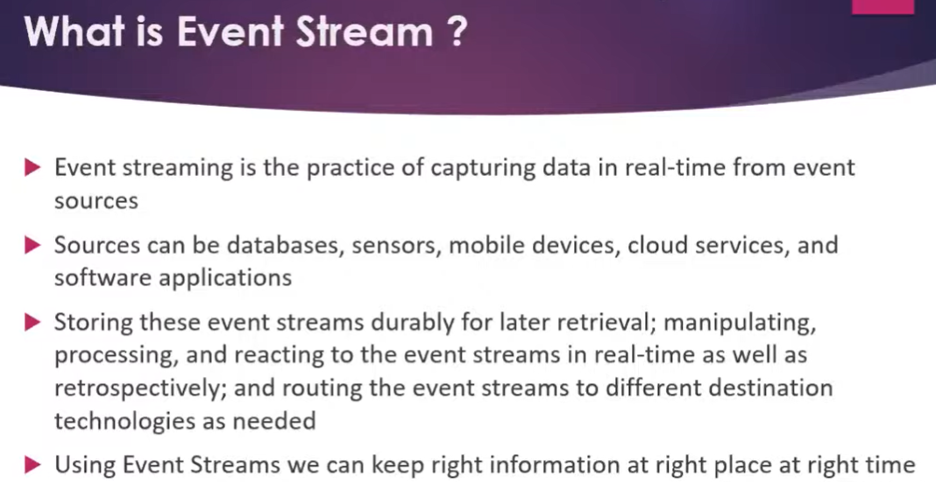

Web services : if you want to access data by exchange or access through other application then go for web services.

MQ :when you want share data from one to other go with MQ.

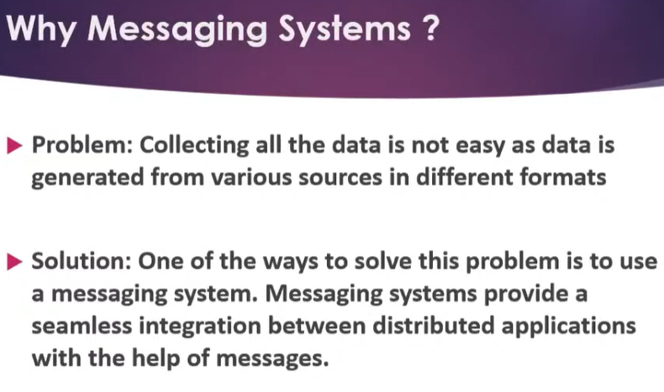

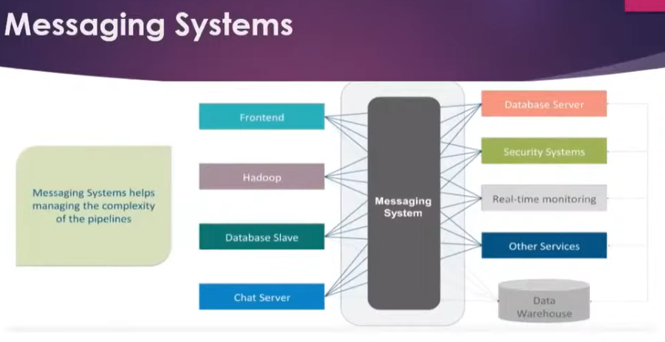

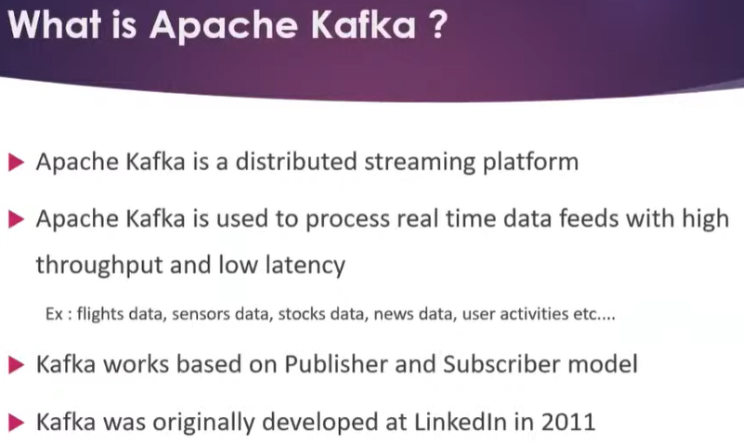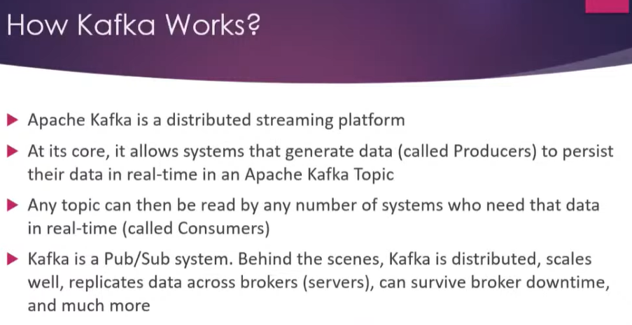

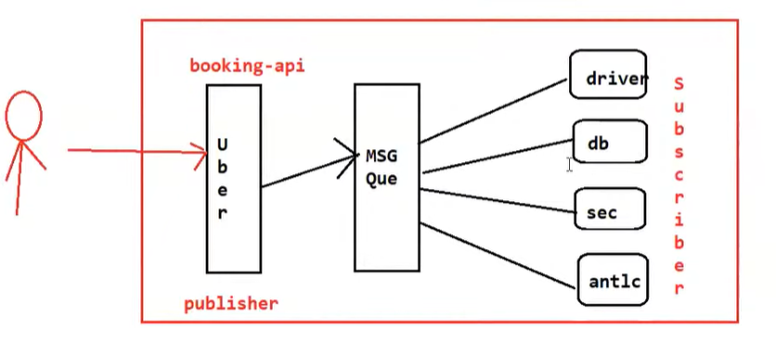

Event driven Microservices:

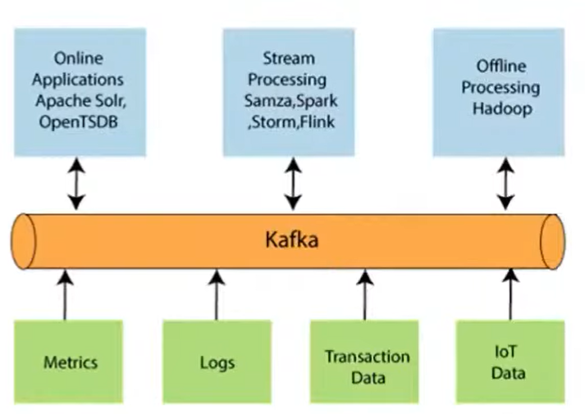

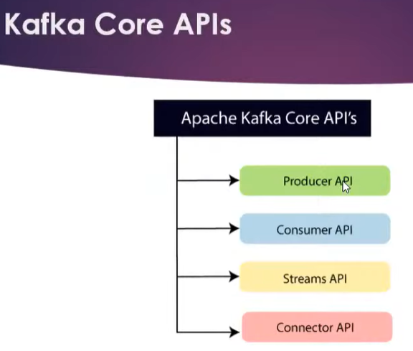

Download zookeeper : <http://mirrors.estointernet.in/apache/zookeeper/stable/>

Set path in system variable on edit : E:\software\kafka\apache-zookeeper-3.6.3-bin\bin

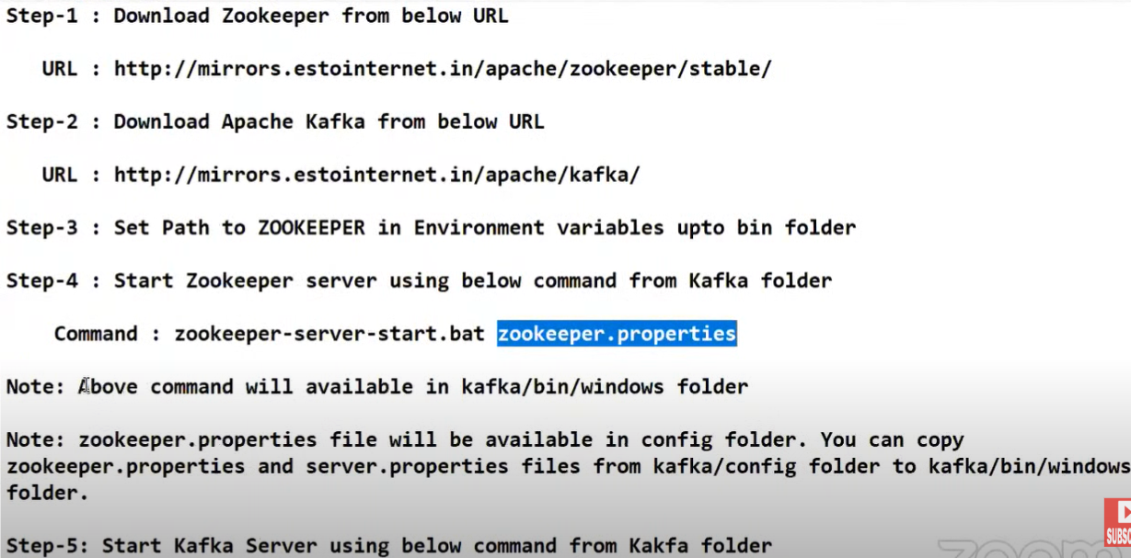

Run inside kafka/bin/windows folder

zookeeper-server-start.bat zookeeper.properties

kafka-server-start.bat server.properties

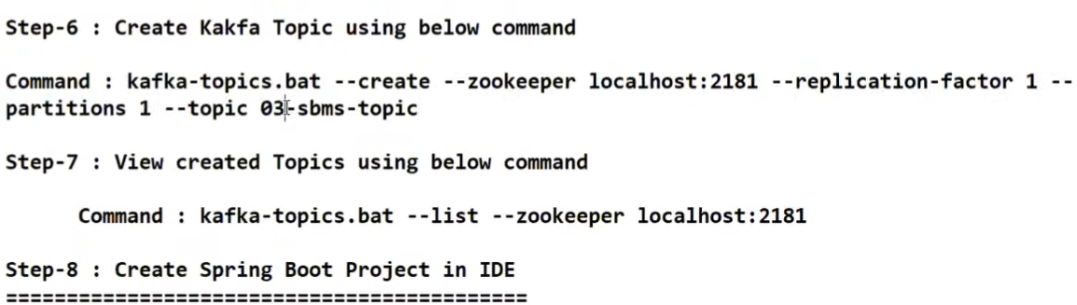

kafka-topics --create --bootstrap-server localhost:9092 --replication-factor 1 --partitions 1 --topic test

kafka-topics.bat --list --bootstrap-server localhost:9092

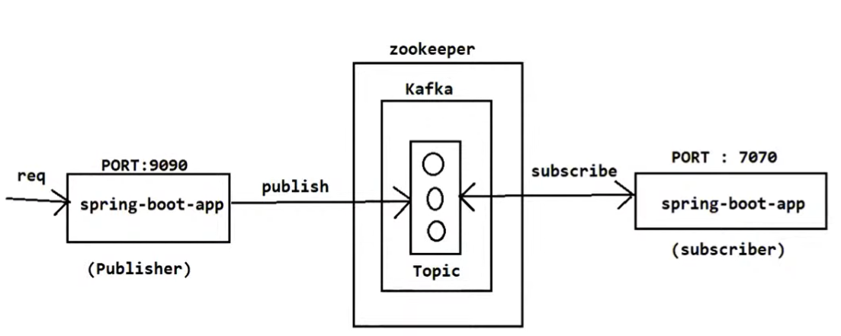

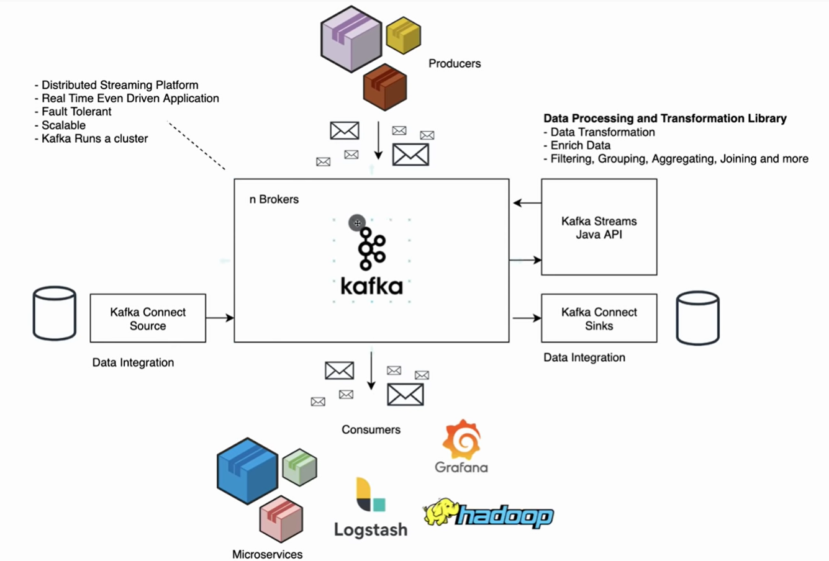

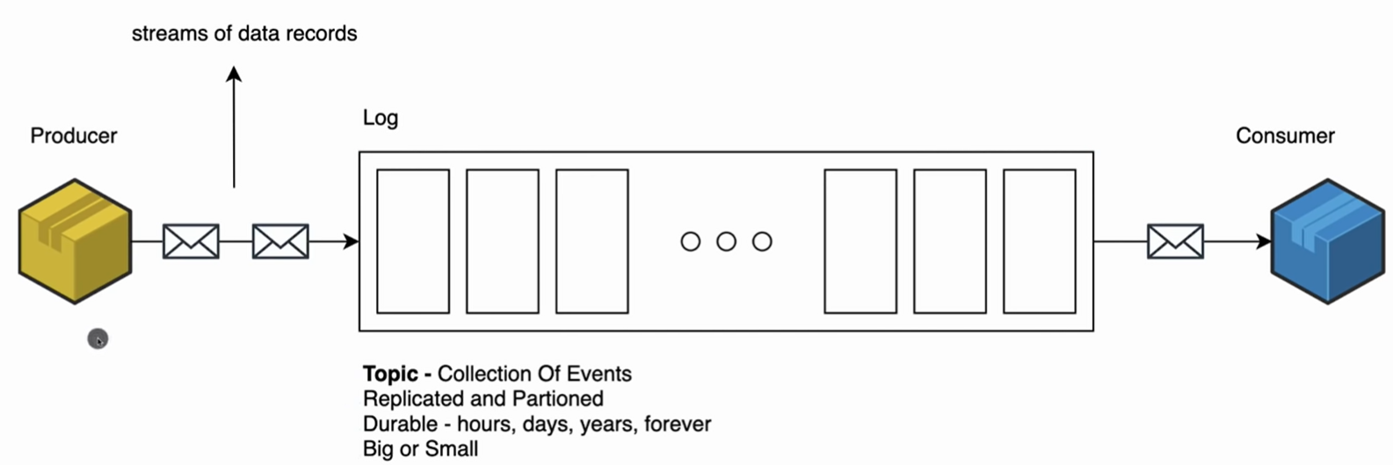

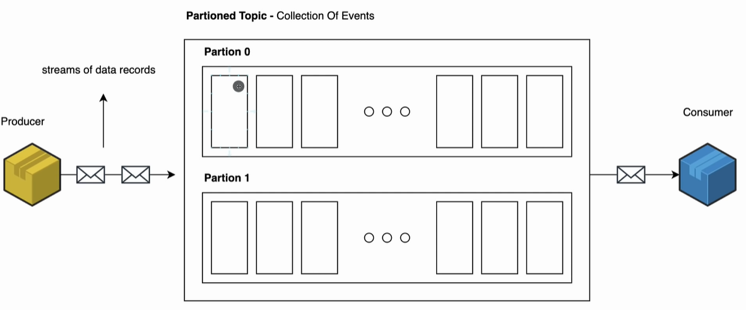

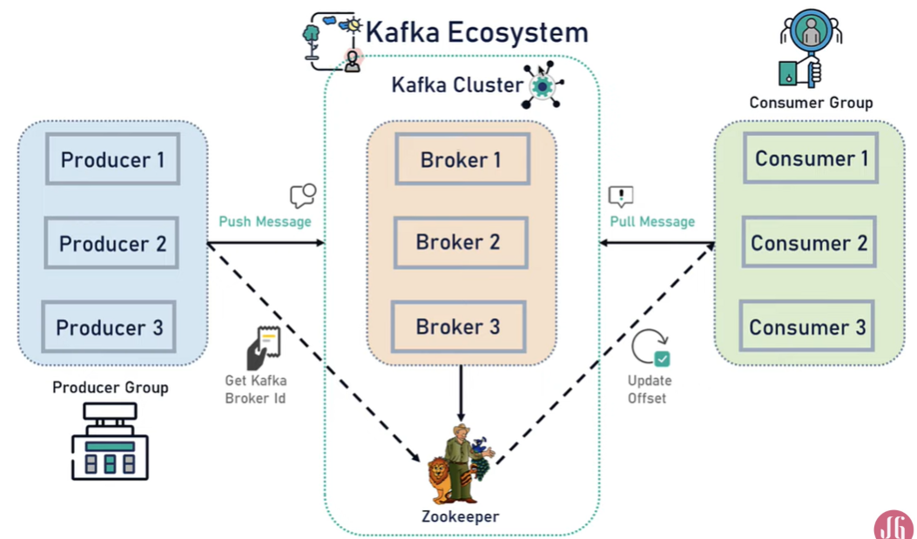

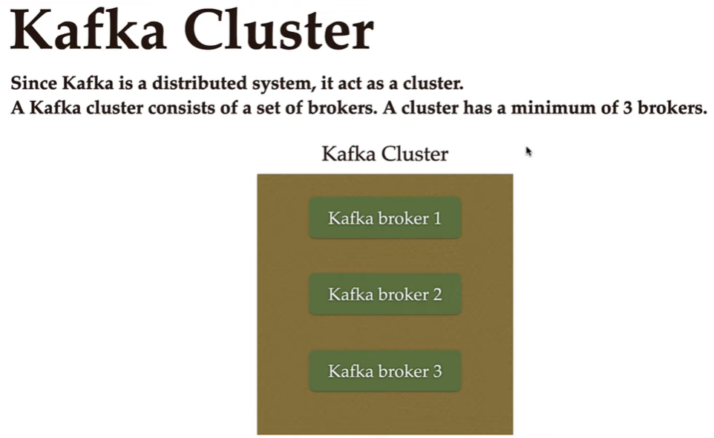

Zookeeper – maintain all configuration of topic and producer and brokers in kafka

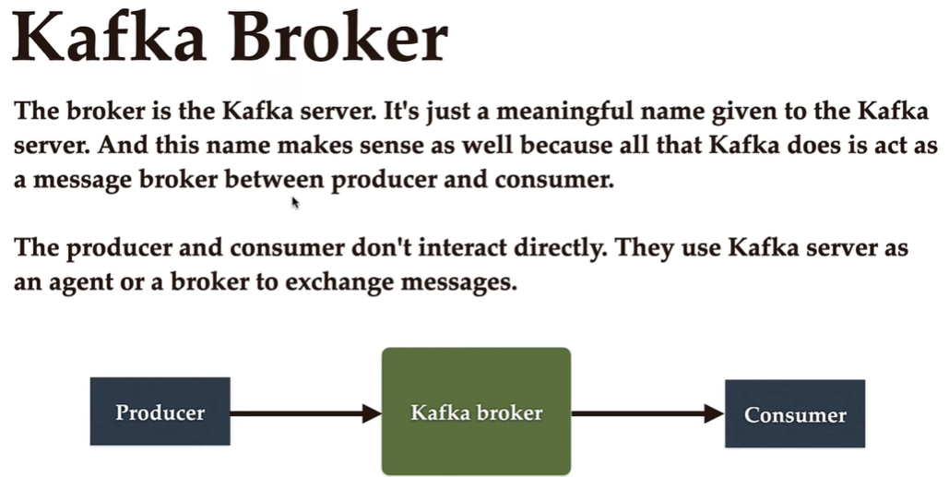

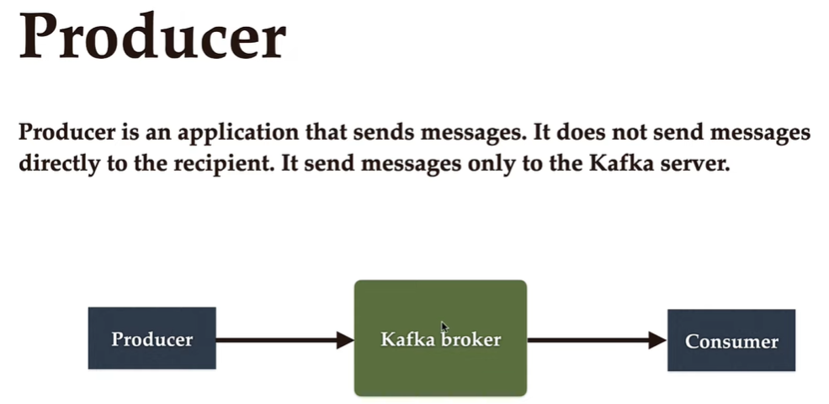

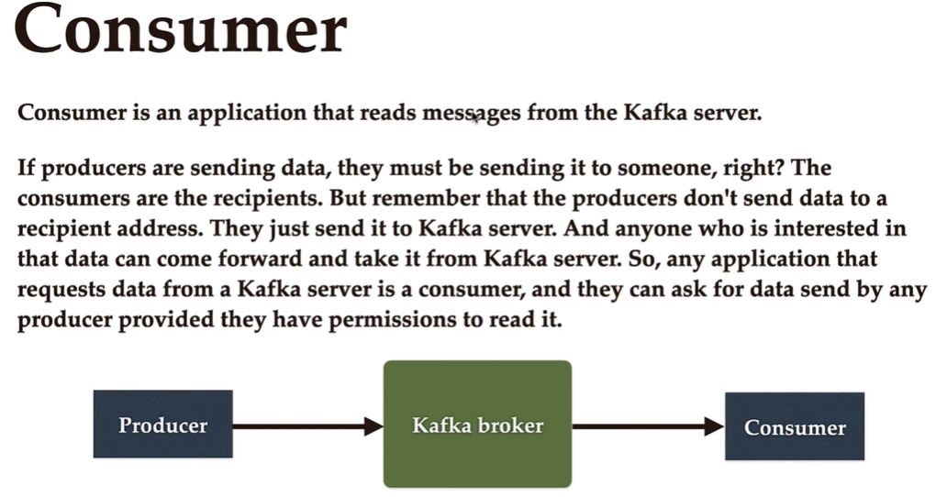

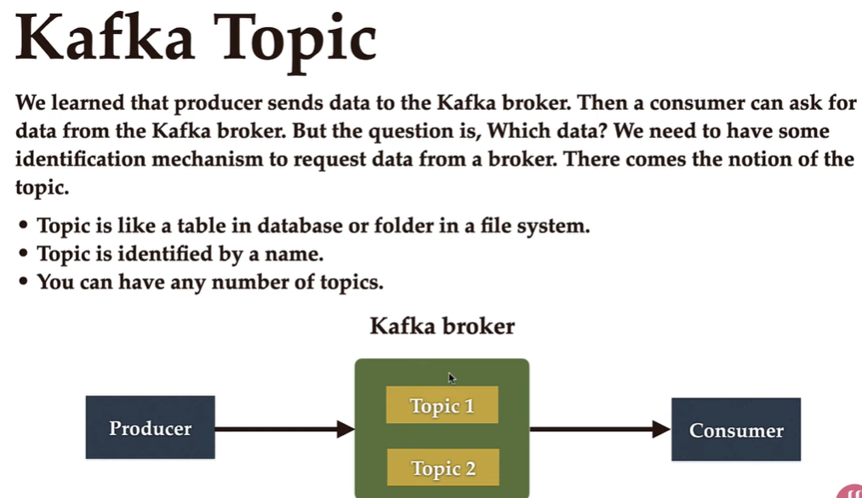

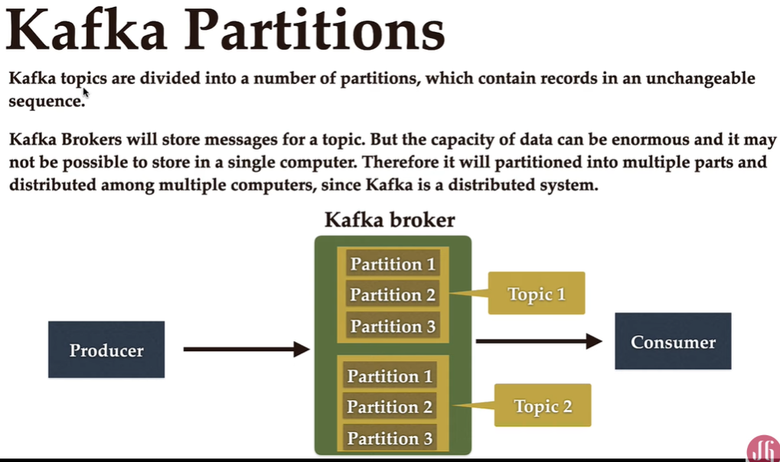

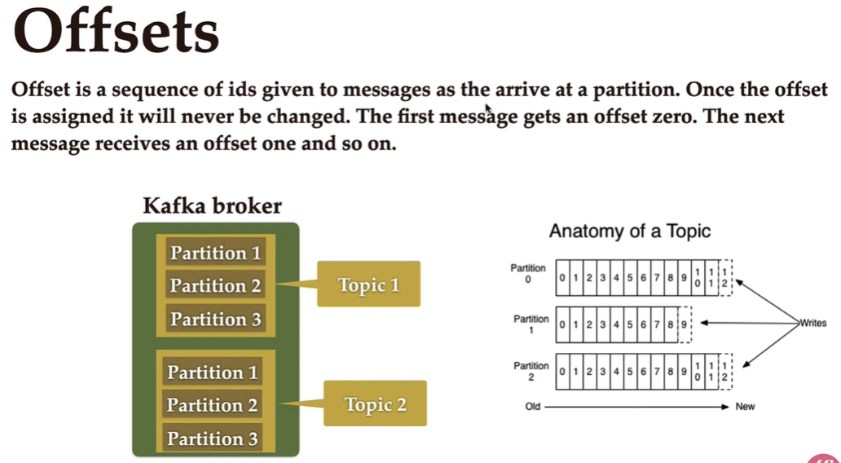

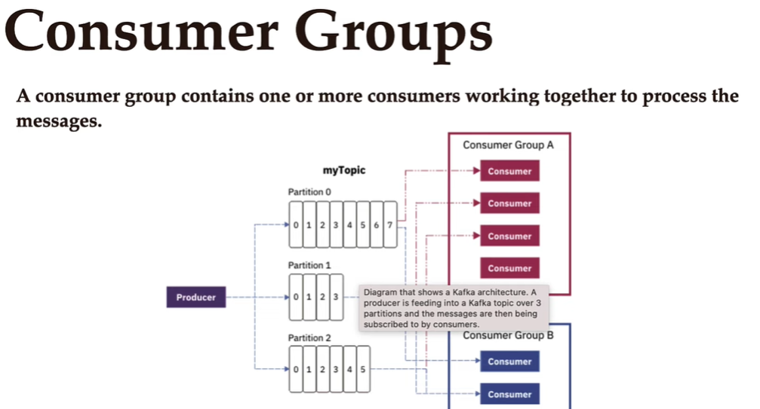

# Start the ZooKeeper service

.\bin\windows\zookeeper-server-start.bat .\config\zookeeper.properties

# Start the Kafka broker service

.\bin\windows\kafka-server-start.bat .\config\server.properties

STEP 3: CREATE A TOPIC TO STORE YOUR EVENTS

.\bin\windows\kafka-topics.bat --create --topic topic_demo --bootstrap-server localhost:9092

STEP 4: WRITE SOME EVENTS INTO THE TOPIC

.\bin\windows\kafka-console-producer.bat --topic topic_demo --bootstrap-server localhost:9092

STEP 5: READ THE EVENTS

.\bin\windows\kafka-console-consumer.bat --topic topic_demo --from-beginning --bootstrap-server localhost:9092

